**Performance Analysis with OAI and NS3**

**Design Document**

**Version 1.2**



**Group Id: F200161379 (BC170402458)**

**Supervisor Name : Arif Husen**

**Revision History**

|  |  |  |  |
| --- | --- | --- | --- |
| **Date (dd/mm/yyyy)** | **Version** | **Description** | **Author** |
| 27/12/2020 | 1.0 | Introduction and ERD added | BC170402458 |
|  |  |  |  |
| 2/12/2020 | 1.1 | Sequence Diagram added |  |
| 10/12/2020 | 1.2 | Architecture diagram and Test cases Added |  |

**Table of Contents**

1. Introduction of Design Document
2. Entity Relationship Diagram (ERD)
3. Sequence Diagrams
4. Architecture Design Diagram
5. Class Diagram
6. Database Design
7. Interface Design
8. Test Cases

1. **Introduction of Design Document**

When partnering with a company during the launch or updating of their application, the process can be expedited if the company utilizes a Solution Design Document (SDD) from a tracking implementation standpoint. An effective SDD should contain all of the parameters being considered within the report suite. It does not have to be complicated to be useful; in fact, if the model is more simplistic, there will be fewer opportunities for error or miscommunication. The beauty of this Solution Design Document is that it allows all parameters to be displayed together at once. Mapping out tracking for site changes. Everyone involved in tracking the application will know which props are able to be used for future tracking outlines what will be measured/tracked on the site. Can be utilized by the team that configures the code for tracking. Reduce ramp up time on establishment of new tracking for new members of the team.   
  
We will be using a 5G simulator like OAI or 5Gs to simulate and a tools to make mobility patterns and test the 5G parameters. This documents explains the design and step to be followed to achieve this goal. All of the information is stored within one central document.

1. **Entity Relationship Diagram (ERD)**

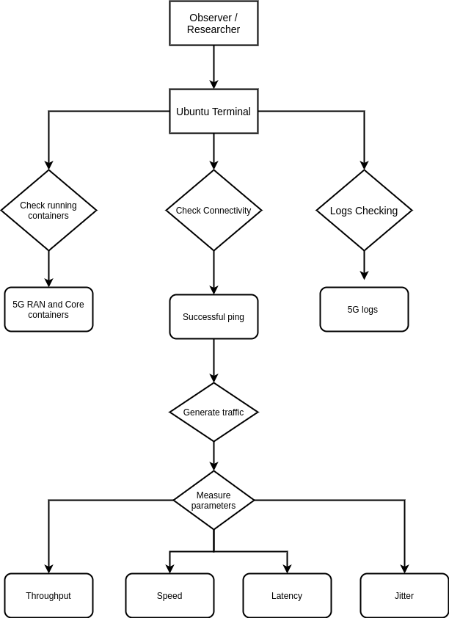

1. **Sequence Diagrams**

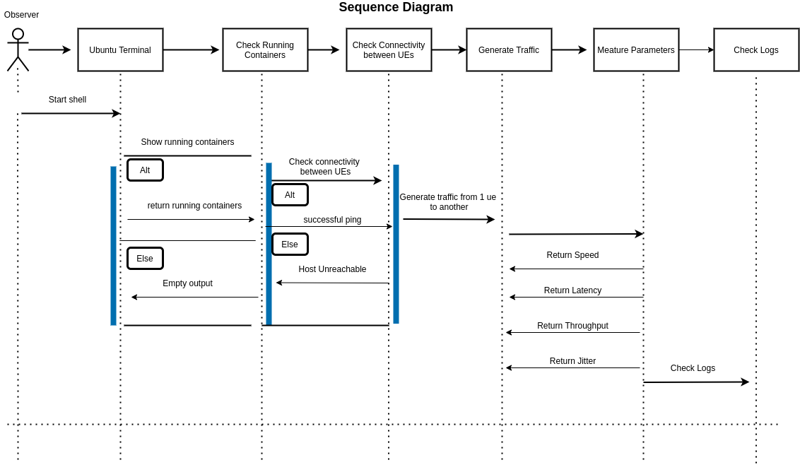

1. **Architecture Design Diagram**

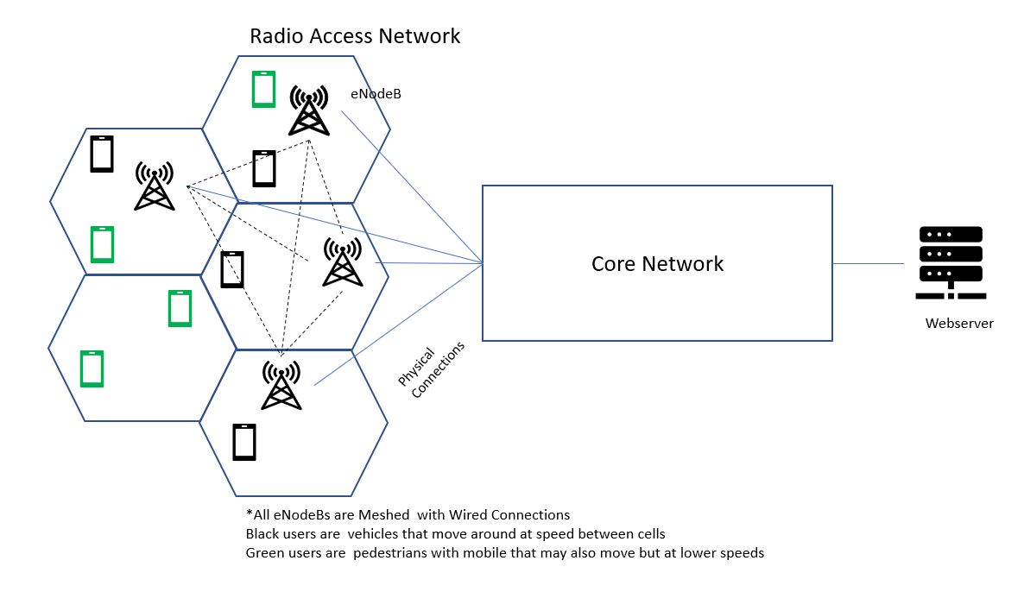

1. **Class Diagram**

Not available as i am not using any classes in my project,

1. **Database Design**

Not available as i am not using any database in my project.

1. **Interface Design**

Not available as there is no GUI in my project and all the testing is terminal (command line) based.

1. **Test Cases**

* **Test case 1**

|  |  |
| --- | --- |
| **Test Case Title** | Check Running containers |
| **Actor** | Observer/Tester |
| **Description** | Observer will check the list of running container and see if all required containers are running. |
| **Alternative Paths** | N/A |
| **Pre-Conditions** | Docker containers must be installed |
| **Post conditions** | Observer will get the list of running containers. |
| **Author** | Muhammad Usman |
| **Exceptions** | nill |

* **Test case 2**

|  |  |
| --- | --- |
| **Test Case Title** | Test connectivity between UEs |
| **Actor** | Observer/Tester |
| **Description** | Observer will test the connectivity between different UEs by pinging each other. |
| **Alternative Paths** | N/A |
| **Pre-Conditions** | UEs must be connected to NodeBs . |
| **Post conditions** | Observer will get the ping result and know if the other UE is reachable. |
| **Author** | Muhammad Usman |
| **Exceptions** | nill |

* **Test case 3**

|  |  |
| --- | --- |
| **Test Case Title** | Generate Traffic from one UE to other |
| **Actor** | Observer/Tester |
| **Description** | Observer will generate traffic from one UE to another in order to measure parameters, |
| **Alternative Paths** | N/A |
| **Pre-Conditions** | All UEs must be connect to NodeBs and NodeBs to the EPC |
| **Post conditions** | Observer will measure the parameters for 5G. |
| **Author** | Muhammad Usman |
| **Exceptions** | nill |

* **Test case 4**

|  |  |
| --- | --- |
| **Test Case Title** | Measure Throughput |
| **Actor** | Observer/Tester |
| **Description** | User will send data via 5G core network and get throughput in result |
| **Alternative Paths** | nill |
| **Pre-Conditions** | Nodes must be connected to each other properly and can communicate with each other. |
| **Post conditions** | Observer will get the results of throughput. |
| **Author** | Muhammad Usman |
| **Exceptions** | nill |

* **Test case 5**

|  |  |
| --- | --- |
| **Test Case Title** | Measure Latency |
| **Actor** | Observer/Tester |
| **Description** | User will send data via 5G core network and get latency in result |
| **Alternative Paths** | nill |
| **Pre-Conditions** | Nodes must be connected to each other properly and can communicate with each other. |
| **Post conditions** | Observer will get the results of latency. |
| **Author** | Muhammad Usman |
| **Exceptions** | nill |

* **Test case 6**

|  |  |
| --- | --- |
| **Test Case Title** | Measure Jitter |
| **Actor** | Observer/Tester |
| **Description** | User will send data via 5G core network and get jitter in result |
| **Alternative Paths** | nill |
| **Pre-Conditions** | Nodes must be connected to each other properly and can communicate with each other. |
| **Post conditions** | Observer will get the results of jitter. |
| **Author** | Muhammad Usman |
| **Exceptions** | nill |

* **Test case 7**

|  |  |
| --- | --- |
| **Test Case Title** | Measure Mobility |
| **Actor** | Observer/Tester |
| **Description** | Observer will send data via 5G core network and get mbility in result |
| **Alternative Paths** | nill |
| **Pre-Conditions** | Nodes must be connected to each other properly and can communicate with each other. |
| **Post conditions** | Observer will get the results of mobility. |
| **Author** | Muhammad Usman |
| **Exceptions** | nill |